info@noahsarkharpenden.co.uk  07984 554536 | 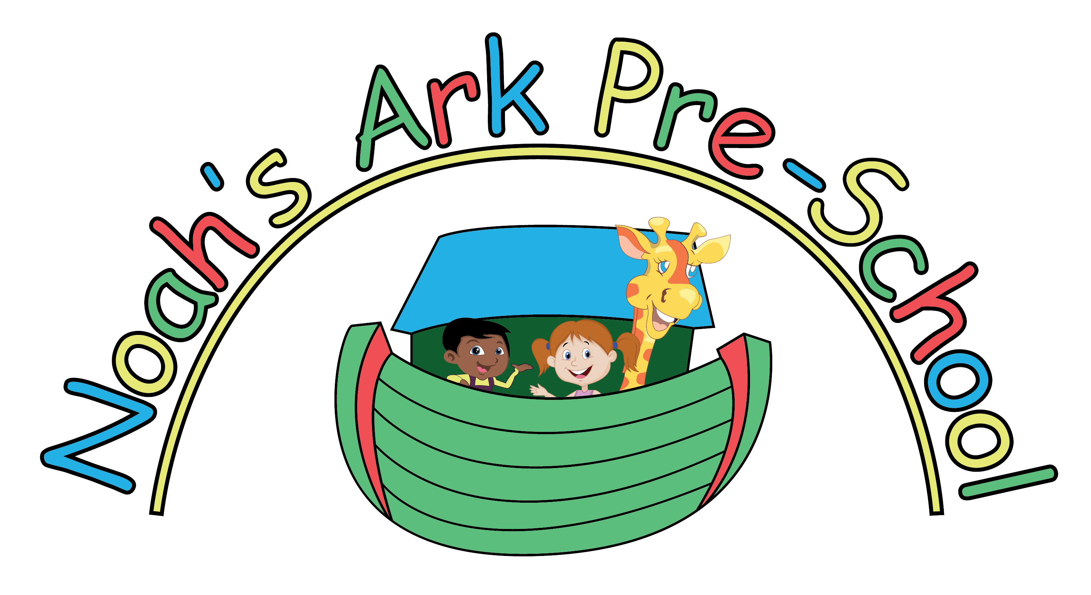 |  | www.noahsarkharpenden.co.uk
Newsletter April 2022

Dear All,

We have many fun activities planned for this term and we are hoping to enjoy some warmer weather and spend more time outside for these activities. We will be covering the themes of Music & songs, growing and gardening, transport and the Queens Jubilee for the first half of term and mini beasts, Father’s Day, under the sea, holidays, journeys, countries around the world, transitions, moving on and holidays for the second half of the term.

We have a photographer coming in this term and the children will have their photos taken outside. If your child is at Noah’s Ark that morning they will be photographed unless you say otherwise. There will be a sign-up sheet if you would like to bring in siblings. If you do not usually attend on that morning, you are very welcome to come.

Drama Llamas will continue to offer storytelling and drama sessions that will take your child on a journey of imagination and discovery and Menace Sports will be introducing the children to tennis and football.

Many thanks,
Denise, Claire and the team

Diary dates
Notable dates:
- Half Term – 30th May–3rd June
- May bank holiday – 2nd May
- Platinum Jubilee Bank Holiday - Friday 17th June
- Photographer – Date tbc
- Father’s Day workshop – Date tbc
- Teddy Bears Picnic and Leavers Ceremony – Fri 22nd July-12.15-1pm
- Fri 22nd July – End of Term

Letters & Numbers:

W/b | 18th April | 25th April | 2nd May | 9th May | 16th May | 23th May | 6th June | 13th  June | 20th June | 27th June | 4th Jul | 11th Jul | 18th  Jul
Letter | Cc | Dd | Ee | Ff | Gg | Hh | Ii | Jj | Kk | Ll | Mm | Nn | Oo
Number | 1 | 2 | 3 | 4 | 5 | 6 | 7 | 8 | 9 | 10 | 11 | 12 | 13

2022/2023 Term Dates:

Summer Term 2022 | Wed 20th April – Fri 22nd July*
May Half Term | 30th May—3rd June 2022
Bank Holiday | Monday 2nd May 2022
Platinum Jubilee Bank Holiday | Fri 17th June 2022
Autumn Term 2022 | Tues 6th Sept–Thu 15th Dec
Autumn Half Term | 24th – 28th Oct 2022
Spring Term 2023 | Mon 9th Jan – Fri 31st March
Spring Half Term | 13th Feb – 17th Feb
Summer Term 2023 | Tues 18th April – Wed 19th July*
Summer Half Term | Mon 29th May - Fri 2nd June
*Morning session only. Term finishes at 1.00pm.

Noah’s Ark Pre-School Information

Daily things to remember….  Please bring in slippers, wellies and a named bag  with a change of clothes and if required nappies  and wipes. This bag can be left at Pre-School  on their peg and the slippers are left in their  named shoe box. No plastic bags please and  please make sure all bags, coats, slippers  and wellie boots are named.  Signing out/Accident Book  The Supervisor for that day will tick your child’s name in the register upon arrival. Staff will sign the register on your behalf once your child has been collected. If your child has had an accident, staff will inform you, giving details and sign the accident book on your behalf.  Parent Rota  We have a new parent rota so if you would like to come along and join in with a session feel free to sign up. This is not a requirement as we do not count you in our staff ratios. It is a nice time for you to see how our morning runs and spend some time with your child. If your child has just started at Noah’s Ark it may be better to wait until they have completely settled before you put your name on the rota to help!  Children’s Medicines  Any medications to be kept at Noah’s Ark must be named, in date, with directions for use and a note from the doctor who prescribed it. Please give these to your key worker or the Supervisor. At the end of each session medications are locked in our filing cabinet.  Teddy Bears Picnic and Leavers Ceremony  All children are invited with their parents, please bring a packed lunch for you and your children. There is no lunch club or afternoon session on this day. The picnic takes place on the grass outside - weather permitting! There will be a teddy bear judging contest (please name all teddy bears) followed by the Leavers ceremony . All children who are leaving us to move on will be invited up to be handed their All About Me learning journal.  .  Warmer Weather  As the weather starts to warm up please could you ensure your child comes to school with sun cream on and a named sunhat. As we like to go outside whatever the weather a spare jumper or cardigan and rain mac in their bag is really useful. |  | Covid 19  From 1 April 2022, anyone with a positive COVID-19 test result will be advised to try to stay at home and avoid contact with other people for five days, which is when they are most infectious. For children and young people aged 18 and under, the advice will be three days and when they no longer have a temperature and are well enough to attend.  E-safety  Please click onto these links for helpful advice and information for parents about online safety for children.  https://www.hertsforlearning.co.uk/blog/screen-time-under-fives  https://www.nspcc.org.uk/keeping-children-safe/online-safety/  Transition  Some of our current children will be moving on in September, so please can you support your child by encouraging them to change their own shoes and put on their own coat to encourage independence. Can you also let us know which school your child will be moving to.  Questionnaires  We will distributing these next half term, we really appreciate your feedback.  Early Starts  We have early session starts from Monday to Friday each week starting at 8:45 & 9:00 at £5.50 & £3.00 per session. If you would like your child to attend, please email us or speak to your key worker  Library books  A table will be out each morning with the library books on for you to change with your child. Please return your book before taking another one. The book bags can be kept on their pegs during the morning then taken home with you at the end of the session  Show and Tell  We have ‘Show and Tell’ at the end of each session, so if your child has a special item they would like to bring in to show everyone, please could it have your child’s name on it where possible.
Lunches

Having a packed lunch away from home is a fun picnic for children. We do encourage healthy eating at Noah’s Ark, but do not wish to make it boring. Please remember we have a no nut policy due to allergies; this includes Nutella spread.

•Carbs – Try different types of bread, multigrain, wholemeal, wraps and so on. Leftovers can be useful and very tasty. Cooked cold pizza tastes great and couscous and pasta are easy to prepare the night before, adding some tasty bits and bobs the following morning, such as cold meat, tomatoes, cucumber, peppers, even cold cooked fish such as salmon.

•Great fillers – Vary the choice of fillers. Children have nothing to look forward to if they know they will be having cheese every day. Try tuna with sweet corn, egg mayonnaise, cooked cold chicken and good quality ham.

•Five a day – We all know how important this is, please try and include a small piece of fruit in your child’s lunch. It can be rather overwhelming for a child to be given a huge apple or banana and will only take a few bites before it is discarded. We ask that grapes, cherry tomatoes, olives, cherries etc (anything that could be a choking hazard) are halved and satsumas are seedless, pre-peeled, and halved. If they are not fruit bats then chopped raw veggies are good, particularly when dipped in hummus.

•Strong teeth and bones – Something dairy generally goes down well. As well as small yoghurts and fromage frais, a pot of rice pudding is something a little different.

•To drink – A named container from home with a small amount of water.

•Extras – Small piece of cake, cereal bar, a couple of biscuits.
There are a couple of items which we try not to encourage, namely crisps (huge salt content), and chocolate (it can become a very sticky mess) as well as being loaded with sugar.

Above all else make it a manageable amount. The children do enjoy sitting down to lunch, just not for too long!

